The University School of Computing and Creative Design
What is the problem we are trying to solve?
Stoke-on-Trent and North Staffordshire needs more skilled people in the fields digital technologies and creative design. We have:
- Rising population of 14-25 year olds
- Digital native and creative workforce poised to gain enhanced employability skills
- Low participation rates entering high-performing local universities, specialising in Computer Science, Games Design, Cyber technologies, Artificial Intelligence and Creative Digital Design.
- Untapped potential to become an established centre for companies providing software development across many applications, with particular strengths in the energy, medical and entertainment sectors.

Who we are and our proposal?
The Potteries Educational Trust, including the City of Stoke on Trent Sixth Form College is an innovative, successful, collaborative Multi Academy Trust with high-performing academies and strong links to all 3 local universities: University of Staffordshire, The University of Derby and Keele University. In addition, the PET is a regional hub for Digital Schoolhouse, Midlands Computing a Regional Computing Hub and Science Learning Partnership

We propose to create an exciting and innovative 16-19 free school with our university partners, whose focus will be on Digital Technologies and Creative Design.
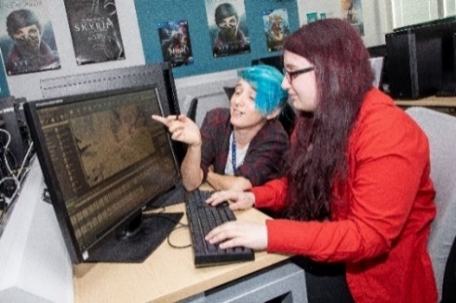
Our University School of Computing and Creative Design will:
- Promote creative problem-solving
- Deliver the highest standards of academic achievement
- specialist curriculum focused on the maths, digital and creative subjects.
- Develop the creative and entrepreneurial spirit
- Employer-focussed: using opportunities from Silicon Stoke Initiative, LEP Skills Advisory Panel (SAP) as well as forming a Business Education Interest Group.
What we need from you:
- Scan the QR Code to complete a letter of support for this exciting project
or
- Share your email and contact details and we’ll send you a template letter of support
- Let us know if you wish to join our virtual Business Advisory Group
Mark Kent, CEO PET and Principal,
City of Stoke-on-Trent Sixth Form College
Tel: 01782 848736
Mobile: 07599421774
Email: mark.kent@stokesfc.ac.uk
About - Potteries Educational Trust PET Website

